LOCATION SCORE Algorithm

**Aim**

The aim is to calculate a score based on which we can compare a location with other similar locations.

**Requirements**

For a particular kind of business we need to find:-

1. Favourable Factors
2. Unfavourable Factors

**Approach**

Suppose we are looking for a prime location for chicken shop.

Favourable Factors within a radius – similar shops, masjid, connectivity, residential areas.

Unfavourable Factors within a radius– schools, colleges, temples, gurudwara.

We just need to find out the frequency of each of the mentioned factors. For eg:- Number of schools within 100m,200m and 500m radius of that shop.

Do this for every factor mentioned.

We will get a table with all the number of factors within a range of radius.

We will calculate a score for favourable and unfavourable factors separately i.e favourable score and unfavourable score.

Final score = Favourable score – Unfavourable score

**To Calculate Favourable score:-**

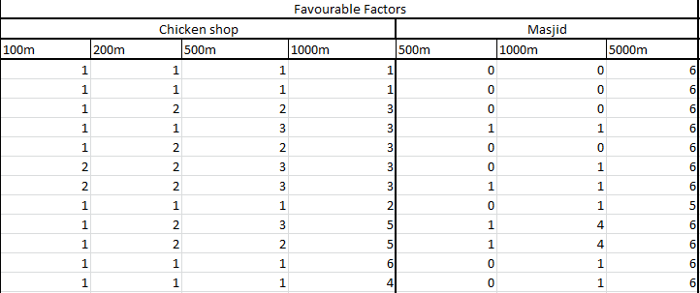

Favourable Score = ∑ value*(weight assigned)

How to assign weights?

|  |  |  |  |  |
| --- | --- | --- | --- | --- |
| Chicken shop | 100m | 200m | 500m | 1000m |
| Weights | 1 | 2 | 3 | 4 |

|  |  |  |  |  |
| --- | --- | --- | --- | --- |
| Masjid | 500m | 1000m | 5000m |  |
| Weights | 1 | 2 | 3 |  |

X(similar shops)=1*1 + 1*2 + 1*3 + 1*4

X(Masjid) = 0*1 + 0*2 + 6*3

Hence adding both these favourable score is evaluated.

**To Calculate Unfavourable score**

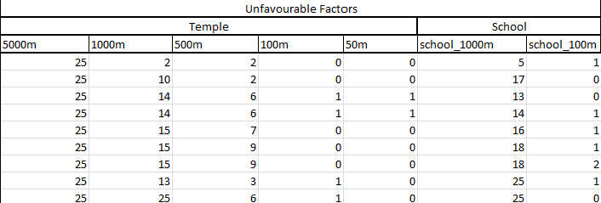

*Approach is similar to that of favourable score*

Hence final score is evaluated using equation below

Final score = Favourable score – Unfavourable score

**INFERENCES**

-More score means more desirable location

-We can look for top 10-15 locations and provide the user with choices among these.